**Design Built and Test Project Report**

**Course Title and Number:**MECE 2361 - Introduction To Mechanical Design

**Semester and Year:**Fall 2024

**Submitted By:***Team 10*

**Team Members:**

* Ibrahim Owonifari
* Maximus Huynh
* Abhi Pastel
* Steven Szaal

**Date of Submission:**November 27, 2024

**Introduction:**

Throughout the design process, our team focused on minimizing the weight and cost of our device. By minimizing the device to our desired weight, we could obtain the 1.75 multiplier for our Figure of Merit. Our design prioritized the collection of sticks and balls to maximize our FoM score. Sticks were indexed as 10 points vs the cone's 7 points. Furthermore, the geometry of the cones made it difficult to collect. In order to capture both the sticks and balls we developed a claw and ramp system that could “claw in” the desired object. Specifically, for the gathering of sticks, a curved section was added to the tip of the ramp so that the sticks would stay secured during transport. To lift objects to zones with different heights, we had a pulley system run by a stepper motor that could raise and lower the claw as needed. One concern we had with this design choice was the speed at which we were able to raise and lower the claw while not overheating the stepper. Gearbox motors allowed the swift movement and speeds were controlled to allow traction. Overall our design was effective at obtaining our goal of the 1.75 multiplier but costing us the operation speed of the pulley system.

Figure 1: Assembly CAD

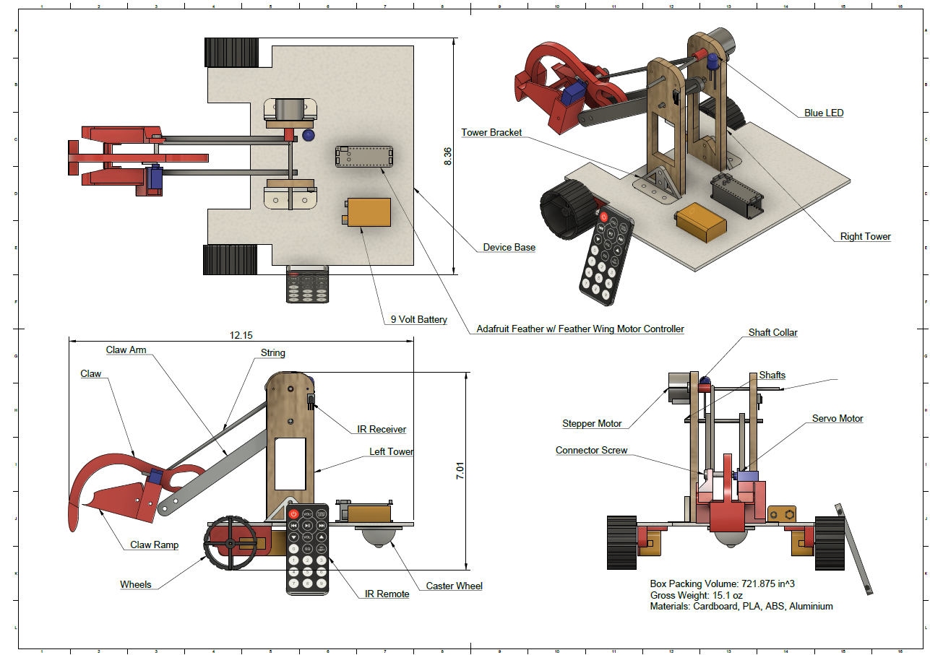

Figure 2: Ortho View Device Figure 3:Top View Device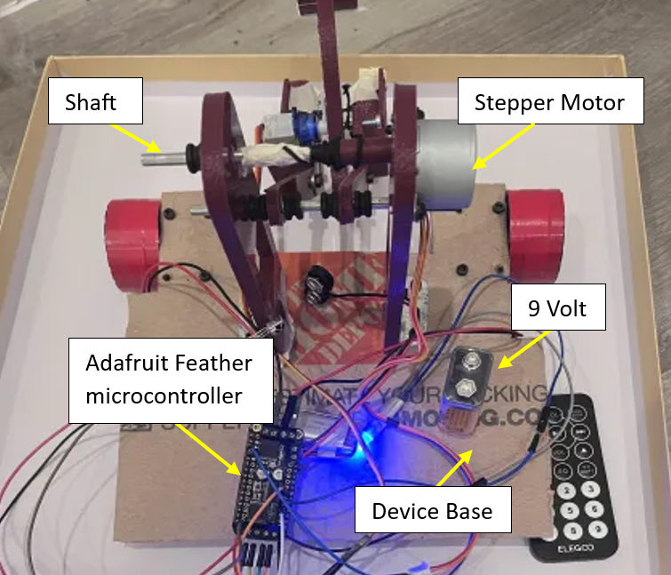

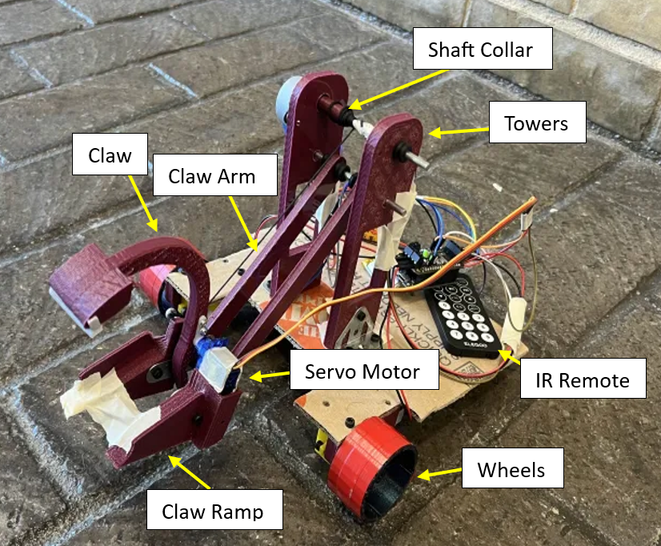

**Device Description:**

***Working Mechanisms / Components -***

Our device incorporates four main sections to gather objects and deliver them to their specific locations.

*Claw & Ramp:*

A claw and ramp system was chosen as the method of collecting objects in zone zero. The ramp is stationary and has a fork design so that balls and cones can sit inside the ramp. At the end of the ramp, there is an arced rim preventing sticks from traveling up the ramp. A Claw attached to a servo extends slightly beyond the ramp allowing objects to be scooped into the forks of the ramp as the servo position is changed.

*Claw Arm Winch Lift:*

The claw arms are lifted via a string attached to a 4 mm connection screw on the ramp. As the stepper motor winds up, the string on the upper shaft creates tension in the string which allows the claw arms connected to the lower shaft to rotate. This raises the claw and ramp system. The stepper is attached to the tower and a shaft collar is used to connect the stepper shaft to the upper aluminum shaft.

*Moving Base:*

Our device has two DC motors with their respective gearboxes and a caster wheel to deliver objects to different zones. The motor and gearbox are attached to the base via a 3D-printed bracket. The gearbox has a shaft which is attached to custom 3D-printed wheels. The wheels were wrapped in electrical tape to enhance traction on carpeted terrain.

*The Brains & Electronics:*

All electronics for the device are controlled using an Adafruit feather w/ a feather wing motor controller. A 5-volt lipo battery was used to supply power to the feather board. A 9-volt battery was used to power the DC and stepper motors. The feather wing controls the stepper and DC motors. The feather board pins are used to power the servo, IR sensor, and LED. The IR sensor takes in data sent from an IR remote and decodes data into a command through the use of an NEC protocol. The LED was used for the initiation of our device.

***Fabrication & Assembly-***

The device was fabricated using a combination of additive and subtractive manufacturing. The base was chosen to be constructed from cardboard for its low weight and structural integrity. The base was cut to size using a box cutter and a drill was used to create holes for fasteners. The claw, fork, arms, shaft collar, wheels, and tower were all 3D printed using PLA filament on a Willson II reprap 3D printer. This was the preferred method of manufacturing as it allowed us to rapidly produce and test prototypes for our claw design. This also allowed us to change the fill density of the parts to reduce weight even further. All components except for the servo and wheels were attached using 3M screws. The wheels and servo were pressed to fit into their proper positions.

***Volume & Weight-***

The device was required to fit within a 1x1 foot square prior to initiation. Our device's dimensions were 8.75 x 11 x 7.5 inches. In total, we were able to lower our device's weight to 15.1 ounces. This allowed us to reach our anticipated weight multiplier of 1.75. Below is a table that contains a list of components with their respective weights and chosen materials.

Table 1: Component Aspects

| **Item / Component** | **Weight** | **Material** |
| --- | --- | --- |
| 9 Volt Battery | 1.6 oz | Steel, zinc, manganese, potassium, graphite |
| Device Base | 2.4 oz | Cardboard |
| Towers | .53 oz / Tower | PLA |
| Stepper Motor | 1.3 oz | Aluminium |
| Servo Motor | .4 oz | ABS |
| Claw Ramp | .74 oz | PLA |
| Claw | .35 oz | PLA |
| Claw Arms | .21 oz / Arm | PLA |
| IR Remote | .5 oz | ABS |
| Wheels | .42 oz / Wheel | PLA |
| Caster Wheel | .4 oz | ABS & Nylon |
| Adafruit Feather w/ Feather Wing | .36 oz | Copper & Fiber Glass |
| DC motor & Gearbox | 1.02 oz | ABS & Aluminum |

**Testing Result and Figure of Merit:**

During final testing, our team received layout three for object layout. This was not the preferred layout since golf balls for test one were further away from the golf ball zone requiring us to use more time to transport objects. Layout two would have been preferred as we had a stronger strategy for this layout in all three tests. With test one we had performed slightly less than expected. During practice, we were able to consistently gather four golf balls within the one minute time period using layout three. During our official test run, we were only able to gather three before the time had elapsed. We narrowed this down to issues in team communication and issues operating the IR remote. The claw and ramp worked effectively at acquiring the golf balls and the device’s base was used to push in balls close to the golf ball zone. In test two we were unable to collect any sticks due to issues with our claw design and slow winch system. When the claw would clamp down on the sticks, they would be pushed underneath the ramp instead of in the designed grove on the ramp. This was noted in practice as well but did not seem like a major problem as it was not a frequent issue. The slow speed of the stepper prevented us from picking up the markers to the desired zone in a reasonable time. In total our team was able to obtain 78.75 points. Below is our tabulated actual FoM and expected FoM breaking down where points were acquired.

Table 2: FoM Scores

|  | Expected FoM | Final FoM |
| --- | --- | --- |
| Index Weight | 1.75 | 1.75 |
| FoM Time | 0 | 0 |
| Index Golf Zone | 5 | 5 |
| Index Zone One | 5 | 5 |
| Index Zone Two | 10 | 10 |
| Index Golf Ball | 3 | 3 |
| Index Sticks | 10 | 10 |
| Index Cones | 7 | 7 |
| Satisfactory Golf Balls | 3 | 3 |
| Satisfactory Sticks (Zone One) | 1 | - |
| Satisfactory Sticks (Zone Two) | 2 | - |
| Satisfactory Cones (Zone One) | 3 | - |
| **Total Score:** | 700 | 78.75 |

**Results Discussion:**

The final design achieved partial success by meeting the requirements of Tier one but fell short of Tier two due to time constraints. During Tier one, The design was able to successfully grab and place ping-pong balls and golf balls into their respective zones, showcasing its functional claw and lightweight mobility. However, it was unable to advance to subsequent tiers involving markers, and cones due to limitations in the claw’s performance and the system’s response.

The design’s lightweight construction was a significant strength, enabling compliance with weight limits and ensuring ease of movement as well as giving a higher score multiplier. Also, the use of a distinct grabbing mechanism demonstrated ingenuity and creativity. However, the claw’s geometry and alignment were not optimized for objects with geometrical figures like markers, which reduced the reliability of the design. The slow response of the stepper motor further compounded this issue, hindering precise and timely movements.

The primary shortcoming was the inconsistent performance of the claw mechanism, specifically its inability to reliably grab and lift markers. This issue came from the geometric figure of the claw, material, and alignment. Also, the stepper motor's slow response compromised the precision and timing of the claw movement. These issues could have been avoided by more prototyping and testing.

In retrospect, the team learned a valuable lesson about the importance of immense testing across all scenarios and the importance of adaptability of design in moments of challenges.

**Recommendation:**

To enhance the device performance and achieve a higher FoM score, the following improvements are recommended:

1. Claw optimization: Redesign the claw to improve its ability to grip smaller cylindrical objects while maintaining the ability to grab golf balls and ping-pong balls

Ex. Adding soft gripping material to the end of the claw for increased object traction, and decreased claw length for better capture of sticks.

1. Motor Reliability: To operate the claw lift faster, increase the speed while increasing the torque of the stepper.

Ex. Identify a new stepper or design a gear ratio to increase speed.

1. Testing with Layout Variability: Practice all potential layouts to develop adaptive strategies.
2. Remote Improvement: Using a radio or Bluetooth-based remote could have improved response time and connection of the remote to the device.

**Conclusions:**

The final device consisted of a ramp, claw, and motor winch system. The claw can clamp down on objects with the use of a servo. After, a string attached to the shaft of the stepper motor could be wound up causing the claw to lift, well above 4 inches, enough for clearance of zone two. The entire device is controlled with an IR remote and Adafruit microcontroller. It moves around using two wheels attached to DC motors, and a rear caster wheel.

The max weight of our device was 15.1 oz and the device can fit in an 8.75 x 11 x 7.5 inch footprint.

Our team saw significant success during the first round, with ping pong and golf balls. We originally decided that out of the three layouts given, the second layout would have been most optimal for our device. The device struggled in round two, as we planned on having 1 stick placed in zone one, and two placed in zone two but instead were unable to gather any sticks in the limited time frame. With the cones, we had anticipated putting three cones into zone one. Due to our 1.75 weight multiplier, we were able to earn a total of 78.75 points with a DQ due to failing the second round.

The key takeaway from this DBT project is that testing your device is very crucial in order to understand the functionality of a device. Having strong communication within the team is also very essential so everyone is on track with what is done and what needs to get done. We have also learned that practice testing results can be significantly different than actual test results, as we saw with our testing. We hope to remember these lessons for upcoming group activities and anticipate applying them in our capstone project.

**Appendices:**

## **Appendix A: Cost List**

| Item: | Price: | Source: |
| --- | --- | --- |
| Adafruit Feather M0 Express | **$19.95** | [Adafruit ESP32-S3 Feather with 4MB Flash 2MB PSRAM [STEMMA QT / Qwiic] : ID 5477 : Adafruit Industries, Unique & fun DIY electronics and kits](https://www.adafruit.com/product/5477) |
| DC Motor + Stepper FeatherWing Add-on For All Feather Boards | **$19.95** | [DC Motor + Stepper FeatherWing Add-on For All Feather Boards : ID 2927 : Adafruit Industries, Unique & fun DIY electronics and kits](https://www.adafruit.com/product/2927) |
| Self Adhesive Caster Wheels | **$8.99** | [Amazon.com: PlusRoc 4 Pack Self Adhesive Caster Wheels For Appliance, Load Capacity 14LBS Per Wheel, Mini Swivel Wheels Sliders Roller For Stand Mixers Air 2Fryers : Industrial & Scientific](https://www.amazon.com/gp/product/B0C69HTGK1/ref=ewc_pr_img_1?smid=A16MBAJLOTGB84&psc=1) |
| DC Motor with Gearbox | **$6.99** | [Amazon.com: Diann 4pcs TT Motor DC 3-6V Gearbox Motor 200RPM Ratio 1:48 Shaft Motor with 2.54mm Wire for DIY Smart Car Robot : Automotive](https://www.amazon.com/Diann-Motor-Gearbox-200RPM-Ratio/dp/B0BR7S2TRY/ref=sxin_16_pa_sp_search_thematic_sspa?content-id=amzn1.sym.76d54fcc-2362-404d-ab9b-b0653e2b2239%3Aamzn1.sym.76d54fcc-2362-404d-ab9b-b0653e2b2239&cv_ct_cx=dc%2Bmotor%2Bwith%2Bgear%2Bbox&dib=eyJ2IjoiMSJ9.f5EU7iHtYNA09c7FI5-ZNvppYXl9ma29znKnyfhXbpJ05xsZlaNCUorJj7v6zwWj6LW-b4Qa3I5lbc08e1mcyw.dIP5zRD8_Kimxe4YtUFkumStFOzWCFIGJFZBdbEs4qM&dib_tag=se&keywords=dc%2Bmotor%2Bwith%2Bgear%2Bbox&pd_rd_i=B0BR7S2TRY&pd_rd_r=f6e5ad42-f88e-4bfc-a7d9-2dec86e45451&pd_rd_w=KHYrQ&pd_rd_wg=FvVRb&pf_rd_p=76d54fcc-2362-404d-ab9b-b0653e2b2239&pf_rd_r=SFMARYEN4YPY5C44GM5P&qid=1732747334&sbo=RZvfv%2F%2FHxDF%2BO5021pAnSA%3D%3D&sr=1-4-6024b2a3-78e4-4fed-8fed-e1613be3bcce-spons&sp_csd=d2lkZ2V0TmFtZT1zcF9zZWFyY2hfdGhlbWF0aWM&th=1) |
| SG90 Servo Motor Micro Servo | **$5.50** | [Amazon.com: ACEIRMC SG90 Servo Motor Micro Servo 9G Servo Motor for RC Robot Arm Helicopter Airplane Remote Control (5pcs) : Toys & Games](https://www.amazon.com/Aceirmc-Helicopter-Airplane-Remote-Control/dp/B081ZY23V4/ref=sr_1_4?crid=15OV3JMA2YSPN&dib=eyJ2IjoiMSJ9.vRG4PTi2MPHsOz44Gbrkggrif_sZ3Dh1_q091jMAzLeX5V8j6tc-oErz48HBaKACQWowy_dWd2qGiCaYyCypK0bXoDl0bReneonRf-6ZmSx3y5RFfyPaDWqt1VzglP5E3cmOb6bVvWwTBk02F2ABmloKbsnm6ri0WyFsyZ1QLpjl5rnAeLjD_TKgmUt8M6qOtZLJP3_kkzKakurlFckt4Ky-VvH4CHMoNsslVSRUlpMAQcr0Ec_Ypcwt7VMp2LuKeoM9bFzJ8m83NDzxc0C7zzDGnbNd9GHKuN1oqxyR08k.u2R5qrOcbOmpzTvhhOsNqSA8yLvbHZc6pNtwEvhVIbg&dib_tag=se&keywords=servo%2Bmotor&qid=1732747423&s=industrial&sprefix=servo%2Cindustrial%2C144&sr=1-4&th=1) |
| 5V Stepper Motor 28BYJ-48 | **$6.99** | [Amazon.com: 5V Stepper Motor 28BYJ-48 with Drive Test Module Board ULN2003 5 Line 4 Phase S : Industrial & Scientific](https://www.amazon.com/dp/B08XGRZJYM/ref=sspa_dk_detail_4?psc=1&pf_rd_p=8c2f9165-8e93-42a1-8313-73d3809141a2&pf_rd_r=XZED3WHYFCEDJBJT21QZ&pd_rd_wg=T83AJ&pd_rd_w=VSPml&content-id=amzn1.sym.8c2f9165-8e93-42a1-8313-73d3809141a2&pd_rd_r=a917cb15-5d14-4b9a-b702-67f93e2b9117&s=industrial&sp_csd=d2lkZ2V0TmFtZT1zcF9kZXRhaWw) |
| 9 volts | **$8.89** | [Amazon.com: Amazon Basics 8-Count 9 Volt Alkaline Performance All-Purpose Batteries, 5-Year Shelf Life, Packaging May Vary : Electronics](https://www.amazon.com/Amazon-Basics-Performance-All-Purpose-Batteries/dp/B00MH4QM1S/ref=sr_1_1_ffob_sspa?crid=2ZSSHV9CIZ9AX&dib=eyJ2IjoiMSJ9.UTIEEJxrXzAacW7rXzP5bfvEuJRS08CBgFJrkRhI2XvGavFFOLFkUVp2HYE8Q1Akez43-BY0EumZpXrfWfRjJgC059r-OEZj9FtNpIhzdPBVHcBGhL88JID08WRe_crqlsobFD636TmCQTNQ7Qr0WHK2YX_i7qSm1yAyzzMvBNqmFHPELAfpGAP6fTbh2wN9li6o8FOQemDn8ZR5vvV8eq-yCEglJQzWG9Nz0Fd_22NrqJLjsX7-Ce9FFY054DLJBMEITUFUqKoG_8oKH-dFsIbC7Bdi7su2HwJE8TnoULs.wJ0CzWk_m2V8BCVmcNotO30-57IF25YaMlEnwPR5cjI&dib_tag=se&keywords=9+volt&qid=1732747596&sprefix=9voly%2Caps%2C135&sr=8-1-spons&sp_csd=d2lkZ2V0TmFtZT1zcF9hdGY&psc=1) |

All items above were purchased to complete the construction of the device. This does not include items the team had prior or any 3D printed materials.

## Appendix B: CAD Representations

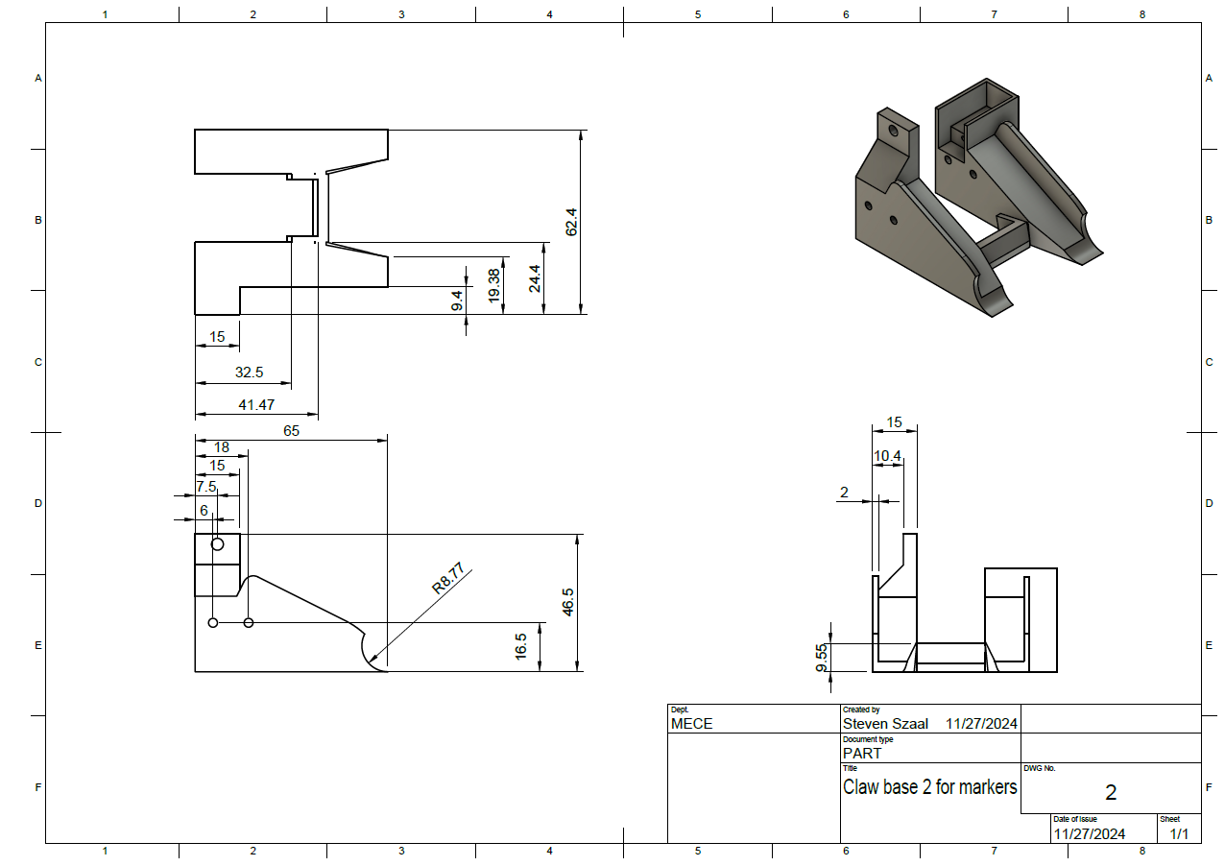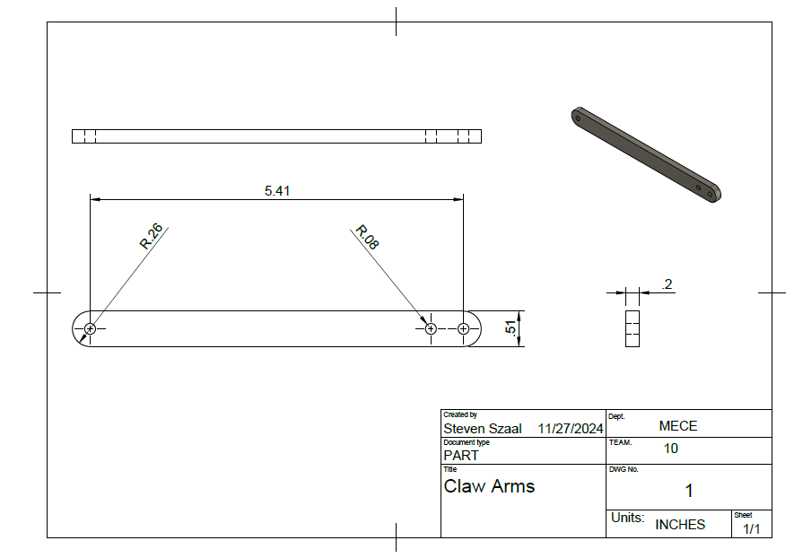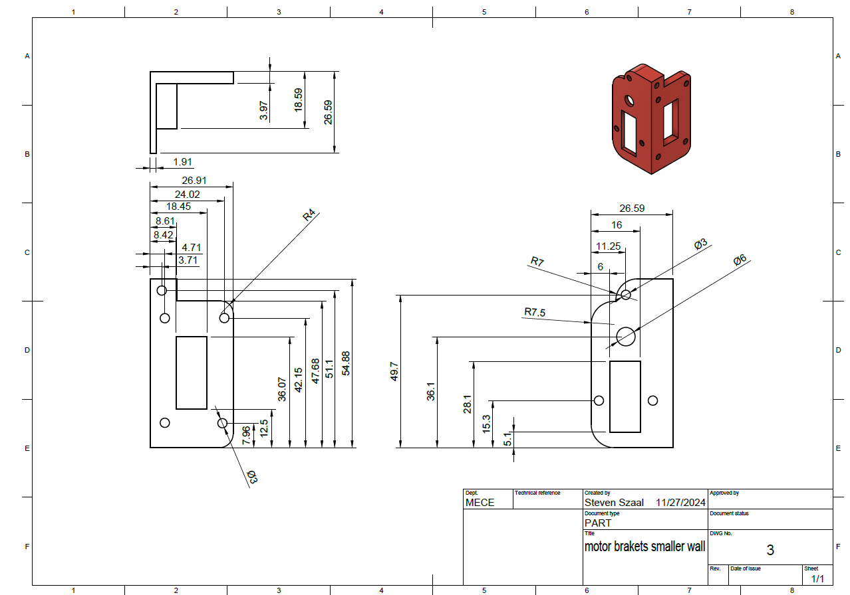

## Appendix C: Part Spec Sheets

28BYJ-48 Stepper - [Microsoft Word - 28BYJ-48 Stepper Motor.docx](https://www.mouser.com/datasheet/2/758/stepd-01-data-sheet-1143075.pdf)

SG-90 Micro Servo - [87897_Datasheet_EN](https://www.kjell.com/globalassets/mediaassets/701916_87897_datasheet_en.pdf?ref=4287817A7A)

Adafruit Feather Wing - [Downloads | Adafruit Stepper + DC Motor FeatherWing | Adafruit Learning System](https://learn.adafruit.com/adafruit-stepper-dc-motor-featherwing/downloads)

Adafruit Feather - [Downloads | Adafruit ESP32-S3 Feather | Adafruit Learning System](https://learn.adafruit.com/adafruit-esp32-s3-feather/downloads)

DC Brush Motor - [NMBTC-DataSheet-DIZ30](https://media.digikey.com/pdf/Data%20Sheets/NMB-MAT/ppn7pa12c1%20data%20sheet.pdf)